Part No. SCREW IN STUDS

The short typical 7/16 screw in stud is too short to properly secure the guide plates. Our longer screw in studs has more treads for better support. You'll need to drill and tap your heads deeper; to accommodate the longer stud to anchor securely otherwise, the heads being aluminum, tend to rip. When doing the final torqueing (after everything is lined up) be sure to use blue Lock Tite and torque to 60-65 lbs.

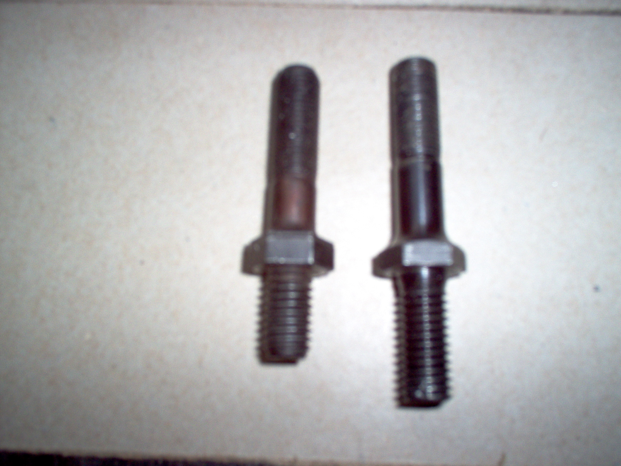

Set of 12 pc…(7/16” base treads)………………………$130.00
Set of 12 pc…(1/2” base treads)……………..…………$150.00

HEAD MODIFICATION FOR MECHANICAL CAM
